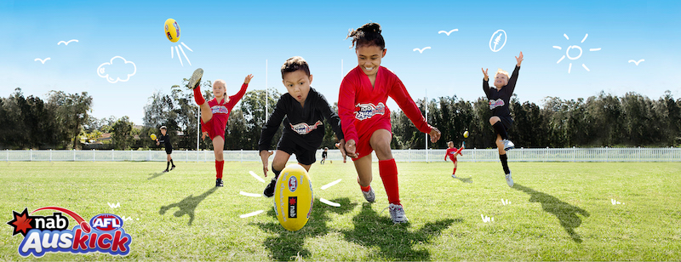
HAMPTON ROVERS 2020 AUSKICK REGISTRATIONS ARE NOW OPEN
Registration and payment can only be made online, so be sure you've registered AND paid to ensure you get your pack full of goodies
Here's the link: http://www.aflauskick.com.au
Whether you are just starting out, or joining for some additional skills training to boost your game, each of our sessions is jam packed with development opportunities, fun and friendships.
We run a GIRLS only group for all ages, play half time games for
Hampton Rovers senior home games and provide a lot of other opportunities
to get your hands on (and feet) onto a footy.
When:
Saturday Mornings: 9.00am to 10.30am Duration: 90 minutes
Start Date: 18/04/20 Finish Date: 8/08/20
Price: $100.00
Hampton Rovers Auskick offers a full range of footy skills for kids aged 5 - 12 years old.
Location Venue:
Boss James Reserve
Cnr David St and Bluff Rd, Hampton 3188
Auskick Coordinators
Andrew Krake Mobile: 0408 646 180
Michael Curtis Mobile: 0428 648 738
Email: auskick@hamptonrovers.com.au
Visit our Website http://www.hamptonrovers.com.au/auskick/

